Virtual Try-On API Integration (Fashn.ai)
We evaluated several virtual try-on solutions and found that Fashn.ai offers the most effective API for our current needs. It is simple to integrate, provides realistic garment-to-model visualizations, and offers a clear pricing model.

Example outputs:

API Endpoint
Base URL for invoking the virtual try-on service:
https://api.fashn.ai/v1/run

How It Works

1. Trigger Virtual Try-On
Use the /run endpoint to initiate the virtual try-on request.
You’ll need to provide:
- model_image: URL of the model wearing basic attire (preferably frontal shot).
- garment_image: URL of the isolated product image (garment).
- category: Type of garment (e.g., tops, bottoms, etc.).
Request:
curl -X POST https://api.fashn.ai/v1/run \
-H "Content-Type: application/json" \
-H "Authorization: Bearer YOUR_API_KEY_HERE" \
-d '{
"model_image": "http://example.com/path/to/model.jpg",
"garment_image": "http://example.com/path/to/garment.jpg",
"category": "tops"
}'

2. Check Status of Image Generation
Use the /status endpoint to check if the try-on image has been generated.
Request:
curl -X GET https://api.fashn.ai/v1/status/{job_id} \
-H "Authorization: Bearer YOUR_API_KEY_HERE"
Replace {job_id} with the ID received in the /run API response.

Rate Limits
Endpoint | Limit
/run | 50 requests per 60 seconds
/status | 50 requests per 10 seconds

Latency
6-12sec

Pricing

- $0.075 per successful image generation
- Minimum purchase: 100 credits (i.e., $7.50)
- https://fashn.ai/pricing

VIRTUAL TRY ON’S:
- FASHN.AI:

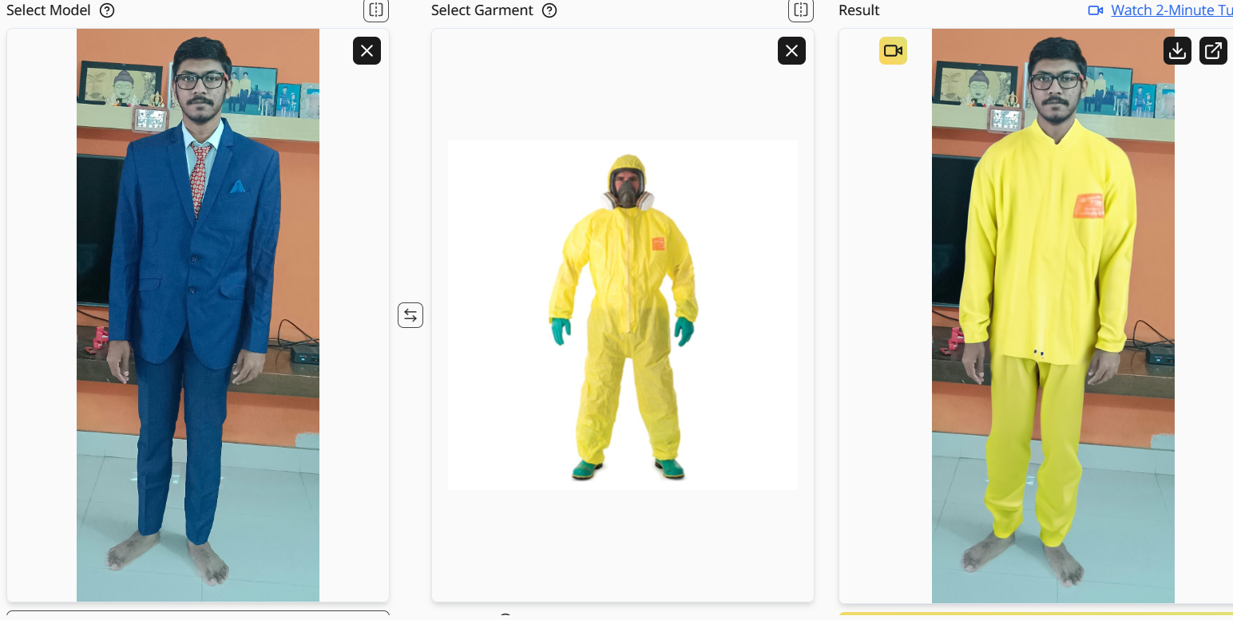
PRICING DETAILS:
- Experimented with free version, might be the Pricing Plan can result better quality o/p
- Minimum 100 images for 7.50 dollars, 1000 for 75 and 10000 for 750 dollars

- SEGMIND
Taking too long to process the image, and the output quality is also too bad, pricing is pay as you go scheme with min 10 dollars (can be ignored)
- PIXELCUT:
The TRY-ON feature is not available for free but other things like background removal, upscaling image, cropping, changing color are available, according to the reviews I saw online, it is worth to take subscription and try the try on feature

PRICING DETAILS:
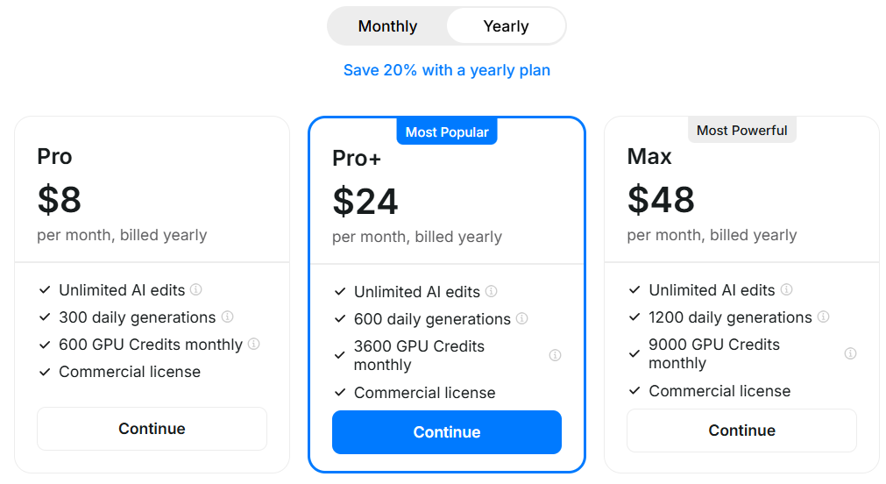
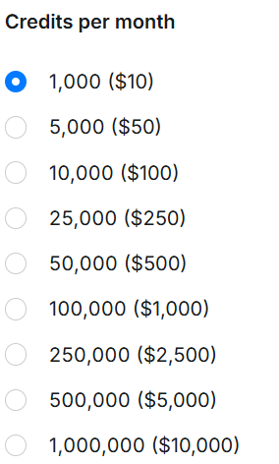

- SellerPic:
Input: (Shirt)
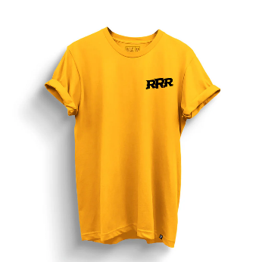
Pant:
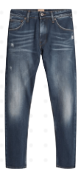
INPUT IMAGE:
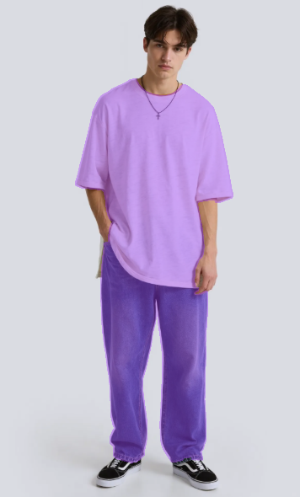
OUTPUT:
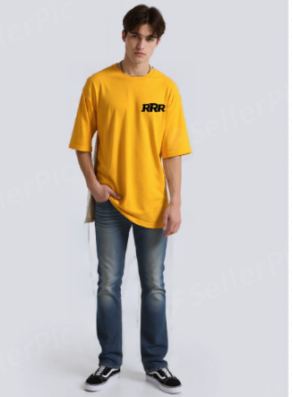
PRICING DETAILS:
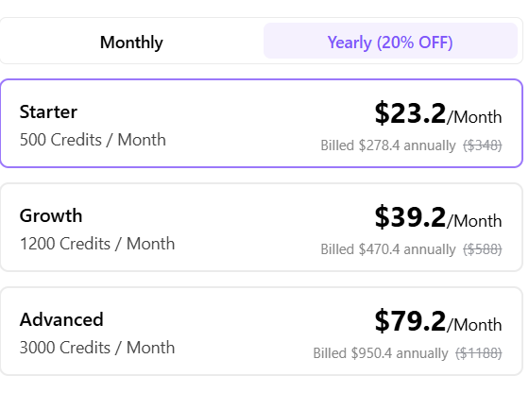

- The New Black – AI Clothes Changer
Input:

OUTPUT:
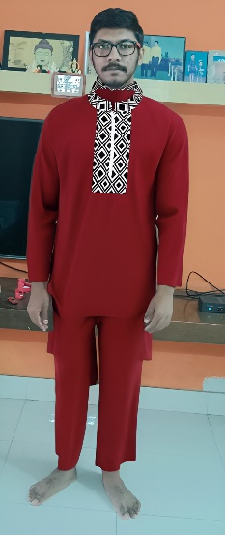
Garment I uploaded:
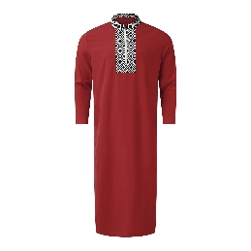
Pricing details:
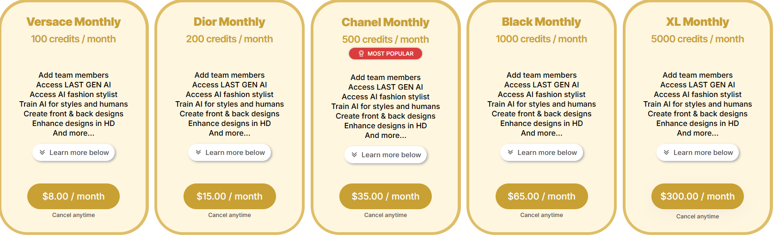
- OutfitChanger.com:
- Seems unprofessional, errors are occurring in many cases, better not to opt and also even in the pro version, results aren’t great, not convincing

- AILab Tools – Try on Clothes API
